Aditi Mallavarapu

CS 412 Homework 1

Problem 1 b).

pkg load statistics

% setup data

D = csvread('iris.csv');

X_train = D(:, 1:2);

y_train = D(:, end);

% setup meshgrid

[x1, x2] = meshgrid(2:0.01:5, 0:0.01:3);

grid_size = size(x1);

X12 = [x1(:) x2(:)];

kcount = [1,2,3,5,10,15]

kndx =1;

neighbors =[];

% compute kNN decision

n_X12 = size(X12, 1);

decision = zeros(n_X12, 1);

for entry = kcount

for i=1:n_X12

point = X12(i, :);

% compute euclidan distance from the point to all training data

dist = pdist2(X_train, point);

% sort the distance, get the index

[~, idx_sorted] = sort(dist);

% find the class of the nearest neighbour

neighbors = idx_sorted;

closest = y_train(neighbors(1:entry));

dec_labels = unique(closest);

count=[1:length(dec_labels)];

for j=1 : length(dec_labels)

for k= 1: length(closest)

temp_label = dec_labels(j);

if (closest(k) == temp_label)

count(j)= count(j)+1;

endif

endfor

endfor

temp = count(1);

max_indx =1;

for j= 2: length(count)

if(count(j) > temp)

temp = count(j);

max_indx = j;

endif

endfor

decision(i) = dec_labels(max_indx);

end

% plot decisions in the grid

decisionmap = reshape(decision, grid_size);

figure, imagesc(2:0.01:5, 0:0.01:3, decisionmap); % plot heading to give

%(entry + "NN decisionmap");

set(gca,'ydir','normal');

% colormap for the classes

% class 1 = light red, 2 = light green, 3 = light blue

cmap = [1 0.8 0.8; 0.8 1 0.8; 0.8 0.8 1];

colormap(cmap);

% scatter plot data

hold on;

scatter(X_train(y_train == 1, 1), X_train(y_train == 1, 2), 10, 'r');

scatter(X_train(y_train == 2, 1), X_train(y_train == 2, 2), 10, 'g');

scatter(X_train(y_train == 3, 1), X_train(y_train == 3, 2), 10, 'b');

hold off;

end

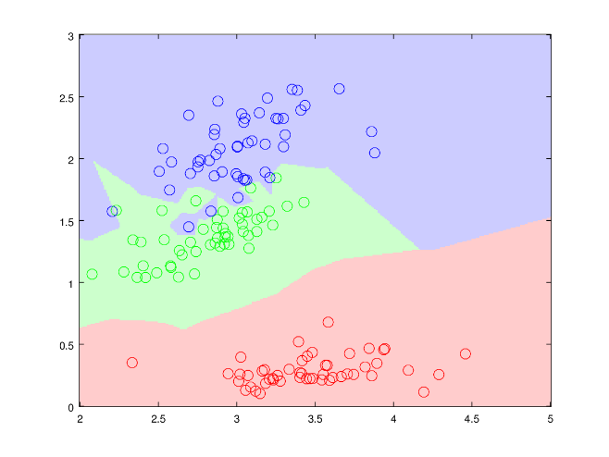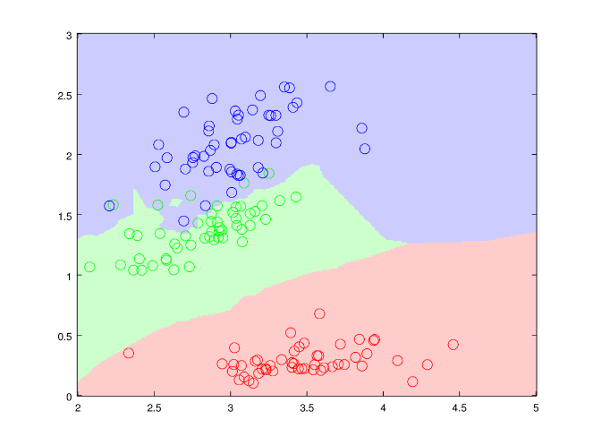

1NN decision Plot 2NN Decision Plot

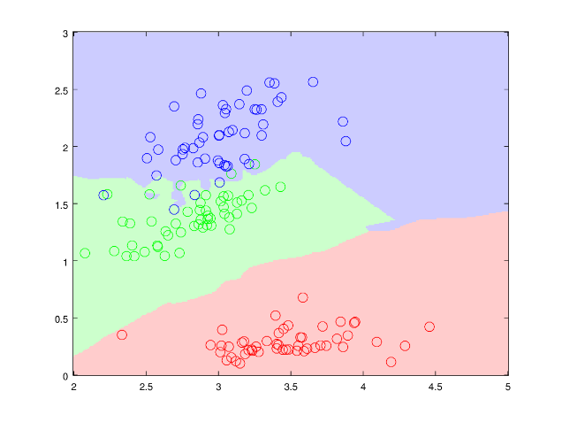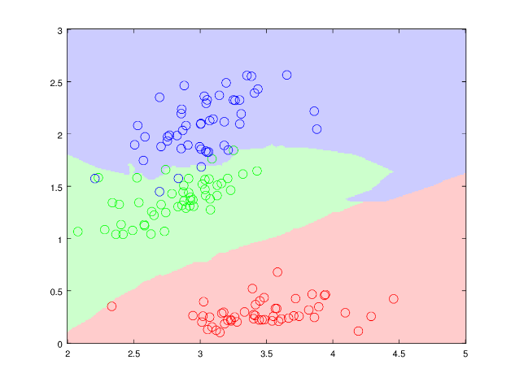

3NN Decision Plot 5NN Decision Plot

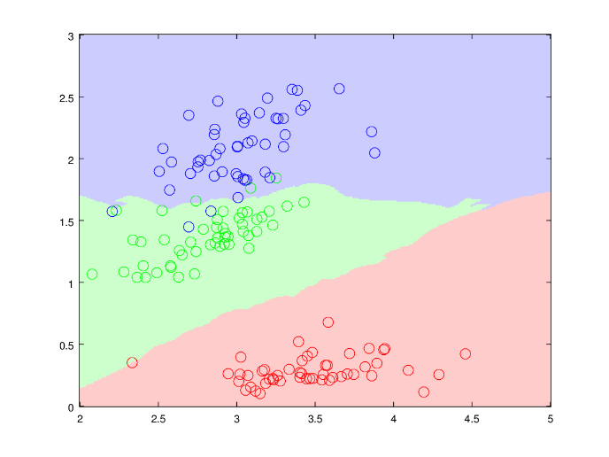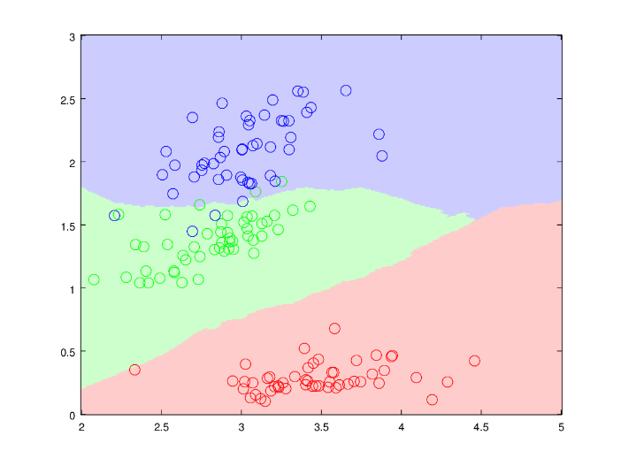

10NN decision Plot 15NN Decision Plot